“I Never Saw Another Butterfly”
Clay tile interpretations inspired from the poetry written by the children in Terezin Concentration Camp during WWII.

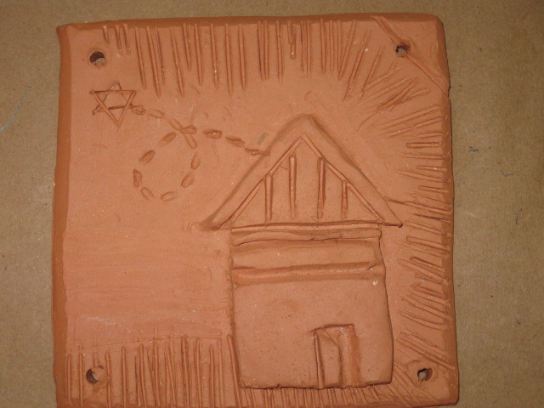

Disseminator: Beth Goldstein
E-mail: bethart@dadeschools.net
School: Miami Springs Sr. High
Mail Code: 7511

SPONSORED BY:

Robert Russell Memorial Foundation

For information concerning IMPACT II opportunities including Adapter and Disseminator grants, please contact:
The Education Fund
305-892-5099, Ext. 18
e-mail: Lvalle@educationfund.org
website: www.educationfund.org
Table of Contents

pages
- Table of contents. . . . . . . . . 2
- Goals, Objectives and Standers. . . . 3-5
- Course Overview. . . . . . . . . . 6-7
- Definition of terms. . . . . . . . 8-9
- Additional Clay terms. . . . . . . 10
- Lesson plans. . . . . . . . . . 11-13
- Resource List. . . . . . . . . . 14-15
- Visuals and student work samples. . . 16-17
- Template for sketching. . . . . . . 18

Objectives, Goals & Standards

Students will gain a better understanding of tolerance and intolerance, with a focus on the events of the Holocaust, and the ghetto of Terezin located in the hills outside Prague. The drawings and poems by the children of Terezin are among the most poignant documents of the Holocaust.

Each student will design three or four tiles that express their understanding of the poems that have been read to them. The tiles may reflect tolerance or intolerance depending on each individual analysis. After each student completes the building and firing of their pieces they will be strung together creating a clay quilt.

To further reach the community and its stakeholders, students will present their completed projects to the community. I plan on having the completed tiles hung in our school gallery windows to be displayed throughout the year. During our school's Literacy Night I will also have students present their completed tiles to the community to share their experiences from creating the tiles to the history they had learned about WWII concentration camps. Students will also present any poetry they have written about the events to the parents.

Visual Arts:

» VA.912.S.3.3: Review, discuss, and demonstrate the proper applications and safety procedures for hazardous chemicals and equipment during the art-making process.
» VA.912.S.3.6: Develop works with prominent personal vision revealed through mastery of art tasks and tools.
» VA.912.S.3.7: Use and maintain tools and equipment to facilitate the creative process.
» VA.912.F.1.4: Use technological tools to create art with varying effects and outcomes.
» VA.912.S.3.9: Manipulate and embellish malleable or rigid materials to construct representational or abstract forms.
» VA.912.S.3.8: Develop color-mixing skills and techniques through application of the principles of heat properties and color and light theory.
» VA.912.S.3.12: Develop competence and dexterity, through practice, in the use of processes, tools, and techniques for various media.
» VA.912.S.3.13: Create three-dimensional modeled and rendered objects in figurative and nonfigurative digital applications.
» VA.912.S.3.10: Develop skill in sketching and mark-making to plan, execute, and construct two-dimensional images or three-dimensional models.
» VA.912.S.3.6: Develop works with prominent personal vision revealed through mastery of art tasks and tools.

Social Studies:

» SS.912.A.1.1: Describe the importance of historiography, which includes how historical knowledge is obtained and transmitted, when interpreting events in history.
» SS.912.A.1.6: Use case studies to explore social, political, legal, and economic relationships
» SS.912.W.1.5: Compare conflicting interpretations or schools of thought about world events and individual contributions to history (historiography).
» SS.912.W.1.6: Evaluate the role of history in shaping identity and character.

Language Arts:

CCSS.ELA-Literacy.RI.9-10.1
Cite strong and thorough textual evidence to support analysis of what the text says explicitly as well as inferences drawn from the text.
CCSS.ELA-Literacy.RI.9-10.9
Analyze seminal U.S. documents of historical and literary significance (e.g., Washington’s Farewell Address, the Gettysburg Address, Roosevelt’s Four Freedoms speech, King’s “Letter from Birmingham Jail”), including how they address related themes and concepts.
CCSS.ELA-Literacy.RI.11-12.7
Integrate and evaluate multiple sources of information presented in different media or formats (e.g., visually, quantitatively) as well as in words in order to address a question or solve a problem.

Overview

This project is designed to be one of the final projects they work on in a ceramics 1 class. Part of my goal is to see how they apply the skills they have learned skills and technique with personal artistic style.

Students will be creating clay tiles inspired by the stories, poetry, and artwork found in the amazing book by Hana Volavková, “I Never Saw Another Butterfly”. Students will understand that the Holocaust was one of the most tragic events in human history that resulted in the deaths of over 6 million Jews and other persons considered undesirable by Nazi Germany under the regime of Adolph Hitler.

The students will be exposed to the innocent and honest depictions of the children that were held at the camp. It will allow the students to see through the eyes of the children what life was like in the ghetto. Birds and butterflies flutter with the looming red roofs of Terezin in the background; a luminous moonlit room betrays the stark interior of the barracks. Pencil line drawings depict the threatening guards, work brigades, and deportations they witnessed. Side by side with the realities are images of hope - a sailboat guided by a candle, a lighted menorah, children playing in a garden that resembles Eden, figures scaling mountain peaks to liberation.

The children's poems and drawings, revealing maturity beyond their years, are haunting reminders of what no child should ever have to see. These students will then use this new knowledge to create their own interpretation of the events.

Definition of terms

Concentration camp: refers to a camp in which people are detained or confined, usually under harsh conditions and without regard to legal norms of.

Genocide: The term "genocide" did not exist before 1944. It is a very specific term, referring to violent crimes committed against groups with the intent to destroy the existence of the group. Human rights, as laid out in the US Bill of Rights or the 1948 United Nations Universal Declaration of Human Rights, concern the rights of individuals.

In 1944, a Polish-Jewish lawyer named Raphael (1900-1959) sought to describe Nazi policies of systematic murder, including the destruction of the European Jews. He formed the word "genocide" by combining geno-, from the Greek word for race or tribe, with -cide, derived from the Latin word for killing. In proposing this new term, Lemkin had in mind "a coordinated plan of different actions aiming at the destruction of essential foundations of the life of national groups, with the aim of annihilating the groups themselves." The next year, the Nuremberg trials held in Nuremberg, Germany, charged top Nazis with "crimes against humanity." The word “genocide” was included in the indictment, but as a descriptive, not legal, term.
(http://www.ushmm.org/wlc/en/article.php?ModuleId=10005143)

Ghetto: from Italian, perhaps shortened from borghetto, diminutive of borgo settlement outside a walled city; or from the Venetian ghetto the medieval iron-founding district, largely inhabited by Jews.

Holocaust: In 1933, the Jewish population of Europe stood at over nine million. Most European Jews lived in countries that Nazi Germany would occupy or influence during World War II. By 1945, the Germans and their collaborators killed nearly two out of every three European Jews as part of the "Final Solution," the Nazi policy to murder the Jews of Europe. Although Jews, whom the Nazis deemed a priority danger to Germany, were the primary victims of Nazi racism, other victims included some 200,000 Roma (Gypsies). At least 200,000 mentally or physically disabled patients, mainly Germans, living in institutional settings, were murdered in the so-called Euthanasia Program.
(http://www.ushmm.org/wlc/en/article.php?ModuleId=10005143)

Racism: the belief that all members of each race possess characteristics or abilities specific to that race, esp. so as to distinguish it as inferior or superior to another race or races.

Symbolism: The practice of representing things by means of symbols or of attributing symbolic meanings or significance to objects, events.

Tolerance: the ability or willingness to tolerate something, in particular the existence of opinions or behavior that one does not necessarily agree with.

Visual Rhetoric: a theoretical and practical investigation of the effects of image-based signifying systems on human subjects in particular situations. We will be talking/listening and reading/writing about seeing with the above considerations in mind.

Additional Clay Terms

Appliqué: A decoration or ornament, as in needlework, made by cutting pieces of one material and applying them to the surface of another.

Incise: mark or decorate (an object or surface) with a cut or a series of cuts.

Relief: Egyptian artisans were masters of painted or drawn, raised and sunk relief work.

Scoring: A technique use to join two pieces of clay together

Sgraffito: Decoration produced on pottery or ceramic by scratching through a surface of plaster or glazing to reveal a different color underneath.

Lesson Plans

The following plan is based on a 55 minute block classes

DAY 1:
Review background knowledge using the definitions provided on the Holocaust and related terminology. Show video if available “The Shadow of Hate” to build on prior knowledge and understanding of intolerance. If “The Shadow of Hate” is not available the following website is a wonderful alterative resource of information.
www.ushmm.org/wlc/en/?ModuleId=10005143‎

DAY 2:
Have a teacher led class discussion on the video or class lecture previously covered. Ask the students to name other events in the world past and present that show intolerance. Ask them to journal about symbolism/visual rhetoric that they could use to convey these ideas. Then ask then to offer ideas on what they can do to teach tolerance to their peers. Again ask them to journal these additional ideas as symbols or visual rhetoric.

DAY 3:
Discuss how quilts have been used to tell different types of stories throughout time. Explain how is this a form of symbolism and visual rhetoric. Introduce the book “I Never Saw Another Butterfly” Copy a few selections or create a PowerPoint presentation from the book to have several students read to their classmates. Model the reading with one poem. Have the class analyze the meanings it could have and the images they could use to symbolize these meanings. Give each student 4 sheets of sketch paper or use the handout provided in this packet. After the students read the additional poems you have selected for them have them create four separate tile designs (one on each sketch paper or handout). Underneath each drawing have them give a written explanation of what they choose and why.

DAY 4:
Have the students work in pairs to review their designs with a peer. Encourage them to get feedback and make modification to the designs if needed to strengthen the symbolism to convey the message they were looking for. A teacher-modeled demo on how to roll out the tiles and prepare the clay for their design should be done.

Days 5 to 7:
Students will work on building their tiles and designing them. It is recommended that the students’ tiles be ¼ of an inch think and no larger than five inches by five inches of design surface. Make sure that at the ends of each class period the students properly cover the clay with plastic to prevent the work from drying out. If the work dies out they will not be able to go back and complete the previous days work. It is also recommended that you repeatedly remind the students they MUST place holes in the work like the sketch so they can be connected.

DAYS 8 to 11:
Now the work will be painted or glazed. Depending on the type of clay, glaze, underglaze, or acrylic paint being used will determine how many days this step will take. Air-dry clay and acrylic paint is usually the fastest.

DAY 12:
The individual tiles are now ready to be strung up or connected. This can be done in set of four as personal mini quilts or as a class project. Use the jute or yarn to connect the pieces. The tighter the yarn the sturdier the larger quilt will be. It can also be tied in vertical strips to make it lighter and easier to hand up for display purposes.

Resource List
Supplies

Newspaper (to cover tables)

“I Never Saw Another Butterfly”, book of poems

Pencil and sketch paper (planning tile design)

Water Spray bottles (to mist project while working and before covering)

Plastic bag (for covering works in progress)

Bat or work board for student use

Clay tools (teachers choice to use some or all of the following list) wooden, loop, spoon, fork, knife, needle, sponge, rib, toothpick and toothbrush

Clay (can be air dry or traditional kiln fire) Approximately 3 lbs per student.

Underglazes, Glaze or acrylic paint if using air dry clay

Measuring sticks

Ruler

Rolling pin

Paintbrushes

Jute or yarn

*All the above supplies can be purchased at Dick Blick, Sax Art Supplies or Jerry’s Artarama

Book of poetry
“I Never Saw Another Butterfly” by Hana Volavková, ISBN
0-8052-1015-6

Video
“The Shadows of Hate” by Charles Guggenheim, available on Amazon

Website
www.ushmm.org/wlc/en/?ModuleId=10005143‎

Samples of students work
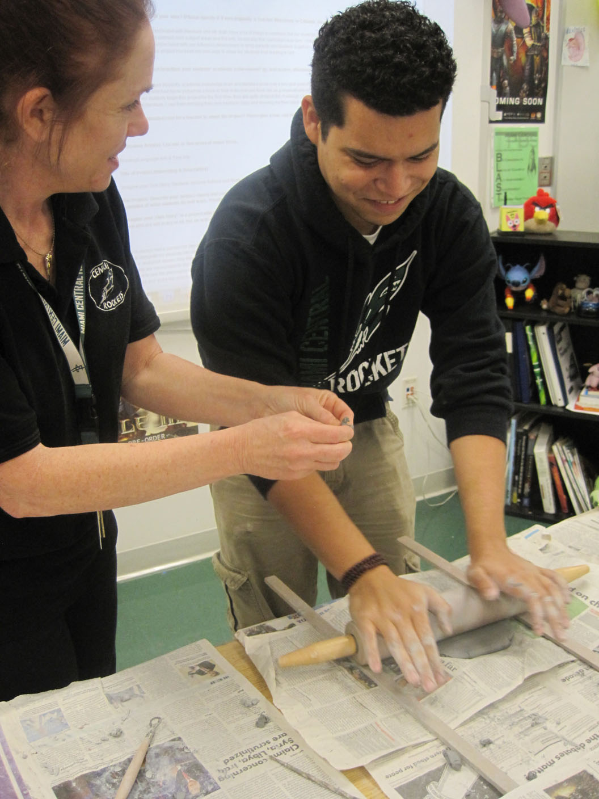
Slab rolling technique
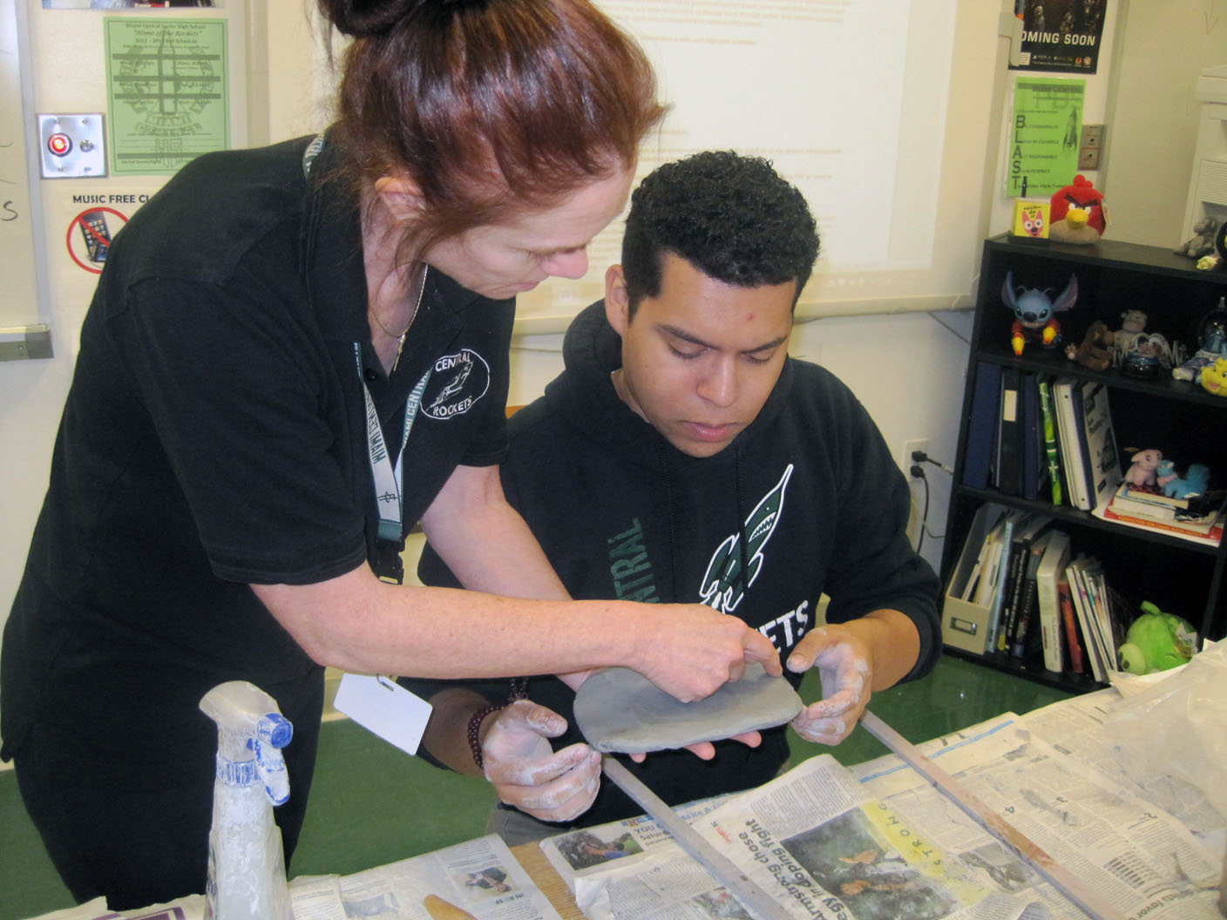
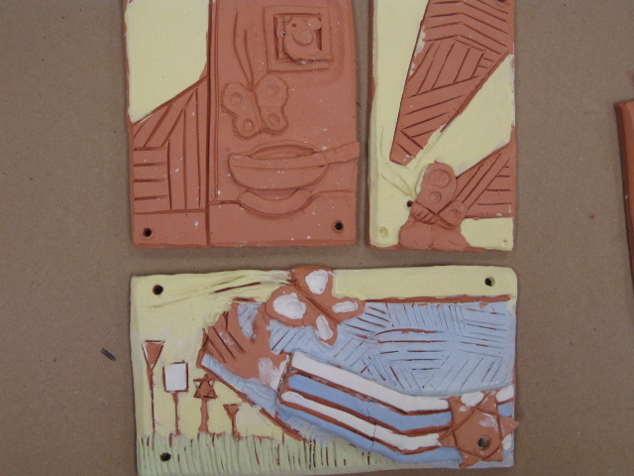
Sample groupings, one student collection above, group below
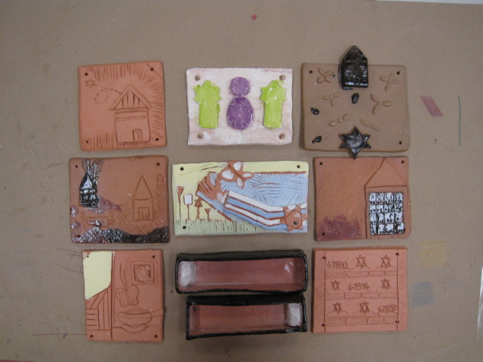
Student Name: Date:
O O

O O

The Education Fund’s

Adapter Grant Application

M-DCPS teachers, media specialists, counselors or assistant principals may request funds to implement an IMPACT II idea, teaching strategy or project from the Idea EXPO workshops and/or curriculum ideas profiled annually in the Ideas with IMPACT catalogs from 1990 to the current year, 2013-14.

Most catalogs can be viewed at The Education Fund web site at www.educationfund.org under the heading, Publications. How-to booklets for each idea can be accessed at www.educationfund.org under Publications. They are listed under Curriculum Idea Packets.
- Open to all K-12 M-DCPS teachers, counselors, media specialists
- Quick and easy reporting requirements
- Grants range from $200 - $400.
- Grant recipients recognized at an Awards Reception in late January.
To apply, you must contact the teacher (the Disseminator) who developed the idea. Contact may be made by attending a workshop at the Idea EXPO given by the IMPACT II disseminator teacher.
Project funds are to be spent within the current school year or an extension may be requested. An expense report with receipts is required by June 15th.
APPLICATION DEADLINE: December 10th.
Apply online at www.educationfund.org.

For more information contact:
Lorna Pranger Valle
The Education Fund
305-892-5099, ext. 18;
Lvalle@educationfund.org

